

Horse Racing Tournament System
Software Requirement Document

– HCM, July 17,2026 –

Record of changeS
Date | A*  M, D | In charge | Change Description
01/Jul/2026 | A | Lam (Lead) | Initial project setup with Spring Boot & SQL Server schema.
02/Jul/2026 | M | Lam (Lead) | Refactored referee and spectator dashboard APIs.
03/Jul/2026 | A | Lam (Lead) | Integrated Gemini AI basic chat service.
04/Jul/2026 | M | Lam (Lead) | Upgraded AI chatbot to RAG and added prompt localization.
05/Jul/2026 | A | Huy (Dev) | Added validation checks for min/max entries in DatabaseInitializer.
06/Jul/2026 | A | Lam (Lead) | Implemented unique gate validation and startup password encryption.
08/Jul/2026 | A | Lam (Lead) | Developed performance charts on spectator dashboard.
14/Jul/2026 | M | Huy (Dev) | Integrated mobile responsive UI updates for landing and calendar.
16/Jul/2026 | M | Nghia (Dev) | Synchronized translation files and profile tabs.
17/Jul/2026 | M | Lam (Lead) | Refactored AI Proxy controller, exposed explicit endpoints and dynamic URL config.
*A - Added M - Modified D - Deleted

Table of Contents
I. Overview 4
1. Introduction 4
2. Existing Systems 4
2.1 System name1 4
2.2 System name2 4
3. Business Process 5
4. System Functions 6
5. Entity Relationship Diagram 7
6. State transition diagram 7
II. Functional Requirements 9
1. <<Feature Name 1>> 9
a. <<Function Name 1>> 9
b. <<Function Name 2>> 9
2. <<Feature Name 2>> 9
III. Database Design 10
1. Database Schema 10
2. Table Detail 10

I. Overview

1. Introduction
The Horse Racing Tournament System (HRTS) is a state-of-the-art web application designed to manage the complete lifecycle of horse racing events, registrations, invitations, and results. By replacing traditional manual and paper-based processes with an automated digital platform, the system ensures real-time updates, strict compliance with tournament rules, and high engagement for spectators. The system is built using Spring Boot for the backend core, a React-based web frontend, and a Python-based AI service utilizing the Google Gemini API for intelligent, data-grounded assistant features.
The Context Diagram below represents the boundaries of the Horse Racing Tournament System, highlighting the relationships and data flows between the central system and its five main external entities (actors):
1. Admin: Manages season rules, creates race schedules, and approves/rejects registrations for horses, jockeys, and owners. Admin receives detailed race schedules and checklists from the system.
2. Horse Owner: Submits registration info for race meetings and manages horse preparations. Owner receives official race results, prize money, and rating updates.
3. Jockey: Receives horse selection invitations, submits weight information during weigh-in/weigh-out procedures, and confirms entries. Jockey receives competition results and rewards.
4. Race Referee: Enters race supervision information, issues incident reports/violations, and confirms the final positions. Referee receives the generated racecard.
5. Spectator: Views live race streams, browses historical statistics, and interacts with the AI Assistant.

2. Existing Systems
[Add the system which might help solving the problems you listed above or the systems in which you can learn/refer the features for your system design]

2.1 Hong Kong Jockey Club (HKJC) Racing Platform
The Hong Kong Jockey Club (HKJC) is a world-class horse racing organization. Its online platform provides comprehensive racecards, real-time odds, results, and detailed horse/jockey performance statistics. While highly professional, HKJC's systems are heavily integrated with complex betting transaction engines, making them closed, legacy-bound, and difficult to adapt for smaller-scale, independent tournament management. The HRTS refers to HKJC's structured racecard layout and class rating system to design its own database and rules.

2.2 Equibase Horse Racing Data System
Equibase is the official database for North American horse racing statistics. It aggregates data from tracks across the continent, providing profiles for horses, jockeys, and trainers. Equibase stands out for its accurate, centralized data collection. However, it operates as a paid data provider and lacks integrated features like real-time spectator chat, interactive AI assistant chats, or native referee-mediated weigh-in workflows. HRTS improves upon this by embedding interactive social features directly into the event stream.

3. Business Process
[This part shows business processes of the system, using swimlane diagram]
<<Sample: shows a partial swimlane diagram for the CTS. The swimlanes in this example are roles or departments, showing which group executes each step in the business process to order a chemical from a vendor.
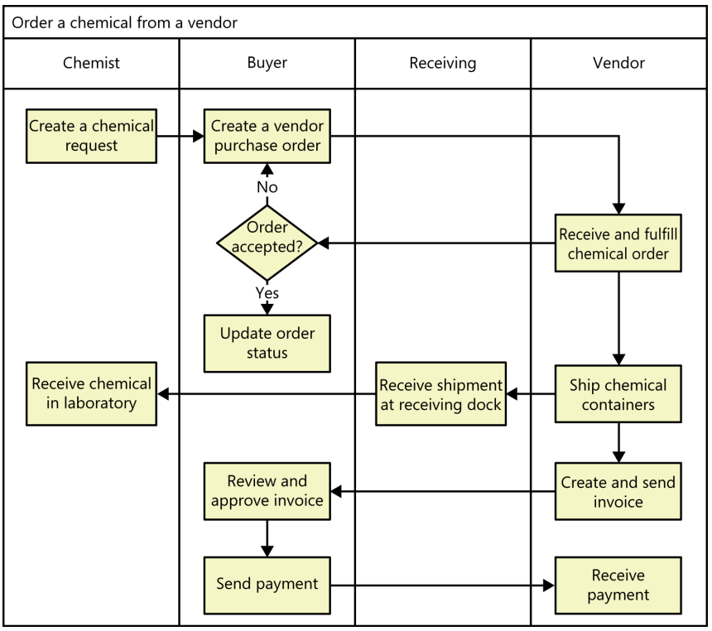
# | Process Step | Description
1 | Create a chemical request | <<Process Step description>>
2 | Create a vendor purchase order
3 | …
>>

4. System Functions

a. Screen Flow
[This part shows the system screens and the relationship among screens. You can draw the Screens Flow for the system in the form of diagram as below]
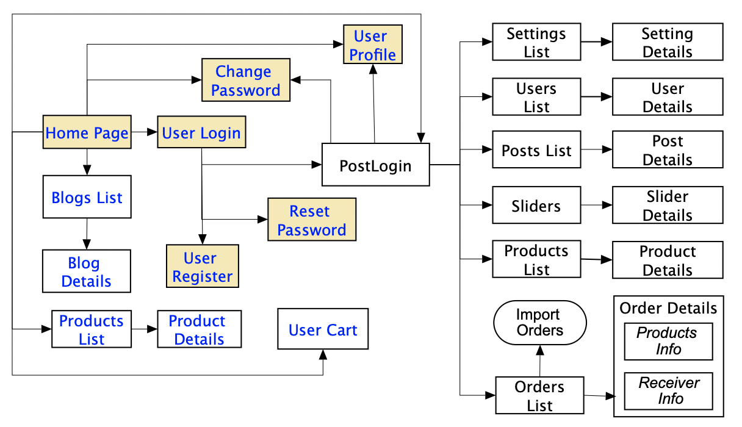

b. Screen Details
[Provide the descriptions for the screens in the Screens Flow above]
# | Feature | Screen | Description
1 | Order Meals | Create Order | <<Screen Brief description>>
2 | Order Meals | Change Order
3 | ..

c. User Authorization
[Provide the system roles authorization to the system features (down to screens, and event to the screen activities if applicable) in the table form as below – replace Role1, Role2,… with the specific system user role names]
Screen | Role1 | Role2 | Role3 | Role4 | RoleX
<<Screen Name1>> | X |  |  | X | X
<<Screen Activity>> |  |  |  | X | X
<<Screen Name2>> | X |  |  | X
Query All Data | X
Query Own Data |  |  |  | X
Query Managed Data |  |  |  | X
Add New Data |  |  |  | X | X
Update All Data |  |  |  |  | X
Update Own Data |  |  |  |  | X
Update Managed Data |  |  |  |  | X
Delete Data
…
In which:
- Role1: <<role1 description>>
- Role2: <<role2 description>>
- …

5. Entity Relationship Diagram
[Provide the entity relationship diagram and the entity descriptions in the table format as below]
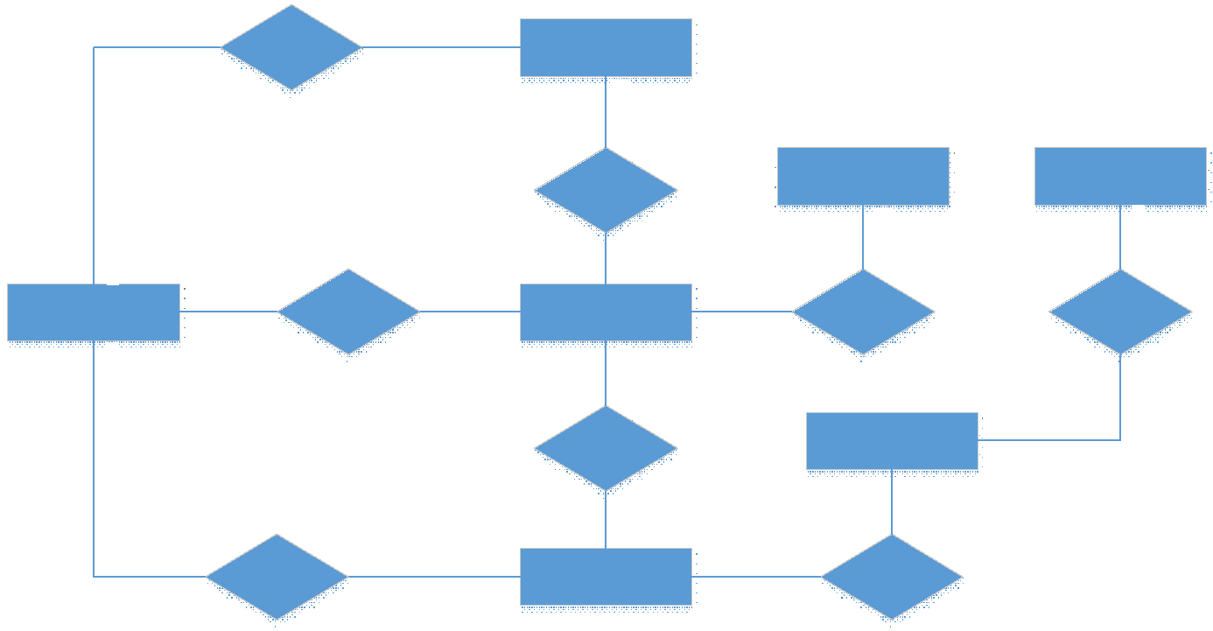
Entities Description
# | Entity | Description
1 | User
2 | Meal
3 | Meal Subscription
4 | …

6. State transition diagram
The system coordinates complex state transitions across three main lifecycles to ensure operational consistency and enforce business rules:
1. Season Lifecycle:
- ACTIVE: The season is open. All registrations, races, and ratings occur within this window.
- CLOSED: The season is archived. Historical ratings and records are locked.
2. Race State Transition (Within an Active Season):
- SCHEDULED: Admin designs and schedules a new race.
- DECLARATION_OPEN: Registration opens; owners register horses and invite jockeys.
- DECLARATION_CLOSED: Registration deadline closes. If registered entries < min_entries, status transitions to CANCELLED.
- RACE_ASSIGNED: Admin approves the entry list, and the system assigns starting gates.
- RUNNING: The referee starts the race, triggering the livestream and live chat.
- STOPPED: Suspended temporarily by the referee for incident review due to a violation. If serious, leads to ENTRY: DISQUALIFIED.
- STEWARDS_INQUIRY: Post-race audit by the referee to inspect potential infractions before finalizing results.
- OFFICIAL: Results are confirmed and finalized.
- RACE_EVENT_ENDED: Ratings are updated, prize money is allocated, and the race event is formally closed.
3. Registration, Invitation & Entry Lifecycle:
- Jockey & Owner Registration: Transition from PENDING to either APPROVED or REJECTED by the Admin.
- Invitation: Created by Owner as PENDING. Transitions to ACCEPTED, REJECTED, or EXPIRED based on Jockey action and deadlines.
- Entry: Created automatically as PENDING_ADMIN when an invitation is accepted. Transitions to APPROVED or REJECTED by the Admin. During the race, entries transition from RUNNING to FINISHED (or DISQUALIFIED).

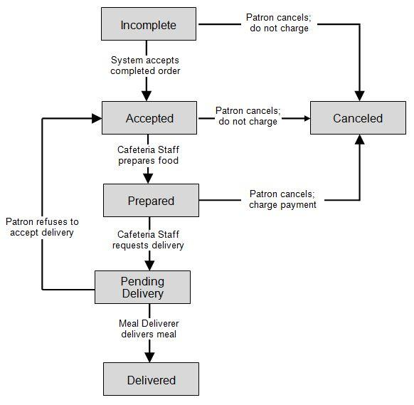

II. Functional Requirements

1. <<Feature Name 1>>

a. <<Function Name 1>>
[A function can be a screen or a non-screen function (listed in the part I.2.d above). In this part, you need to provide the details on the related function, focus on mentioning below information
- Function trigger: how this function is triggered (navigation path, a timing frequency, etc.)
- Function description: actors/roles, purpose, interface, data processing, etc.
- Screen layout: mockup prototype of the screen, sample below is for Manage Products screen
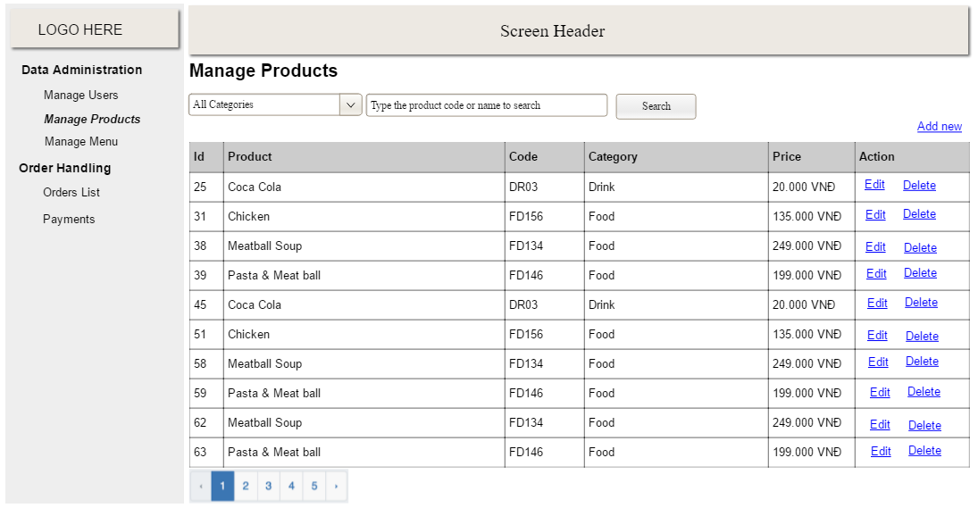
- Function Details: provide explanation for the data, validation, business logics, functionalities (for both normal cases and abnormal cases), etc. of the function so that the reader can image how it work.
]

b. <<Function Name 2>>
…

2. <<Feature Name 2>>
…

III. Database Design

1. Database Schema
[Provide the tables relationship like example below – following MySQL database naming convention]
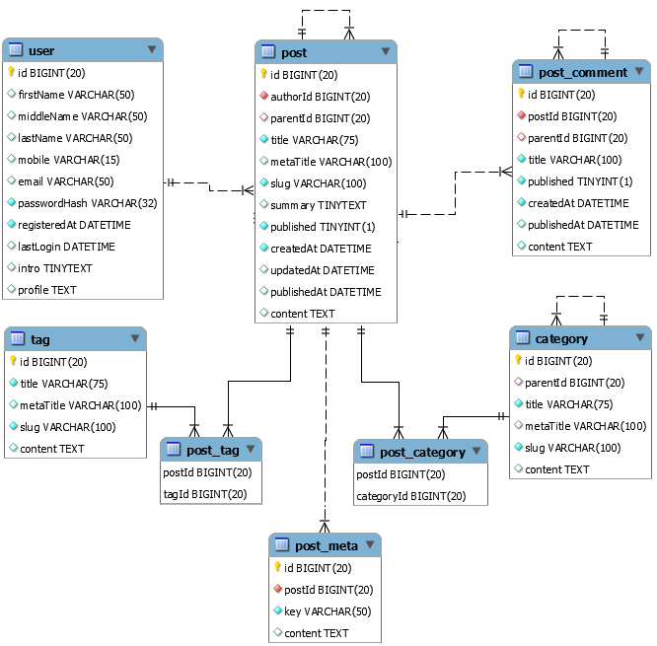
Table Description
No | Table | Description
1 | SystemConfig | Stores global key-value configuration parameters (e.g. weights, allowance).
2 | Role | Defines user authorization roles (Admin, Owner, Jockey, Spectator, Referee).
3 | User | Stores credentials, roles, profile info, and jockey performance history.
4 | Season | Represents tournament racing seasons (e.g. 2026-2027 Grand Prix Season).
5 | SeasonClassRule | Defines rating eligibility limits and prize money ranges for each race class.
6 | RaceMeeting | Represents a racing event day (e.g. Spring Gold Cup Day) grouping several races.
7 | JockeyRaceMeetingRegistration | Tracks jockeys registered and approved to compete in a specific race meeting.
8 | OwnerRaceMeetingRegistration | Tracks horse owners registered and approved for a specific race meeting.
9 | HorseRaceMeetingRegistration | Tracks horses registered and approved to participate in a specific race meeting.
10 | Race | Stores individual race details (purse, distance, class, track type, status).
11 | Horse | Stores horse profiles, current rating, breeding, sex, and career stats.
12 | RaceInvitation | Manages invitations sent by horse owners to jockeys for specific races.
13 | RaceEntry | Maps horse-jockey pairs to starting gates, storing finish positions, times, and ratings.
14 | RaceReferee | Maps referees assigned to supervise specific races.
15 | Violation | Records infractions, penalties, and referee decisions during races.
16 | ChatMessage | Stores live chat messages exchanged during active race livestreams.
17 | HorseRetirementRequest | Manages retirement requests submitted by owners and approved by admins.

2. Table Detail
[Give some lines about the table here>>
[Table fields, in the form of table format as below]

[Table] User
# | Field name | Type | Size | Unique | Not Null | PK/FK | Notes
1 | id | INT | 4 | Yes | Yes | PK | Identity (1,1) auto-increment
2 | role_id | INT | 4 | No | Yes | FK | References Role(id)
3 | username | VARCHAR | 100 | Yes | Yes | - | Unique login username
4 | password_hash | VARCHAR | 255 | No | Yes | - | BCrypt password hash
5 | email | VARCHAR | 150 | Yes | Yes | - | Unique user email
6 | status | VARCHAR | 20 | No | Yes | - | ACTIVE or INACTIVE (Default ACTIVE)
7 | weight | DECIMAL(5,2) | 5 | No | No | - | Weight of Jockey in kg
8 | total_races_participated | INT | 4 | No | No | - | Total career races (For Jockeys)
9 | total_top3_finishes | INT | 4 | No | No | - | Total career top-3 finishes (For Jockeys)
10 | require_otp | BIT | 1 | No | Yes | - | 2FA OTP flag
11 | avatar | VARCHAR(MAX) | - | No | No | - | Base64 avatar image string
12 | full_name | NVARCHAR | 100 | No | No | - | Display full name (Editable)
13 | biography | NVARCHAR(MAX) | - | No | No | - | Personal jockey/user biography

[Table] Race
# | Field name | Type | Size | Unique | Not Null | PK/FK | Notes
1 | id | INT | 4 | Yes | Yes | PK | Identity (1,1) auto-increment
2 | race_meeting_id | INT | 4 | No | Yes | FK | References RaceMeeting(id)
3 | start_time | DATETIME | 8 | No | Yes | - | Race scheduled start time
4 | registration_start_time | DATETIME | 8 | No | Yes | - | Registration open time
5 | registration_end_time | DATETIME | 8 | No | Yes | - | Registration deadline
6 | status | VARCHAR | 50 | No | Yes | - | Race status (SCHEDULED, RUNNING, etc.)
7 | class_level | VARCHAR | 50 | No | No | - | Class rating division (e.g. Class 1)
8 | min_rating | INT | 4 | No | No | - | Minimum rating eligible to enter
9 | max_rating | INT | 4 | No | No | - | Maximum rating eligible to enter
10 | distance_meters | INT | 4 | No | No | - | Track distance in meters
11 | track_type | VARCHAR | 20 | No | No | - | Turf or Dirt
12 | purse | DECIMAL(18,2) | 9 | No | Yes | - | Total purse prize money
13 | min_entries | INT | 4 | No | Yes | - | Min entries required (Default 3)
14 | max_entries | INT | 4 | No | Yes | - | Max entries allowed (Default 14)
15 | steward_report | NVARCHAR(MAX) | - | No | No | - | Steward/Referee report summary
16 | youtube_live_url | VARCHAR(500) | 500 | No | No | - | YouTube live stream embed URL

[Table] Horse
Stores the profiles of participating horses, career stats, and owner information.
# | Field name | Type | Size | Unique | Not Null | PK/FK | Notes
1 | id | INT | 4 | Yes | Yes | PK | Identity (1,1) auto-increment
2 | owner_id | INT | 4 | No | Yes | FK | References [User](id)
3 | name | VARCHAR | 150 | Yes | Yes | - | Name of the horse
4 | breed | VARCHAR | 100 | No | No | - | Breed/Breed group of the horse
5 | sex | VARCHAR | 20 | No | No | - | Gelding, Colt, Horse, Filly, Mare
6 | date_of_birth | DATE | 3 | No | Yes | - | Date of birth of the horse
7 | status | VARCHAR | 20 | No | Yes | - | ACTIVE, INJURED, RETIRED
8 | current_rating | INT | 4 | No | Yes | - | Performance rating (Default 52)
9 | total_races | INT | 4 | No | Yes | - | Total races run career
10 | total_wins | INT | 4 | No | Yes | - | Total wins career
11 | avatar | VARCHAR(MAX) | - | No | No | - | Base64 image avatar of the horse
12 | description | NVARCHAR(MAX) | - | No | No | - | Horse description details
[Table] RaceEntry
Maps horse-jockey combinations to specific race starting gates, recording results and weights.
# | Field name | Type | Size | Unique | Not Null | PK/FK | Notes
1 | id | INT | 4 | Yes | Yes | PK | Identity (1,1) auto-increment
2 | race_id | INT | 4 | No | Yes | FK | References Race(id)
3 | horse_id | INT | 4 | No | Yes | FK | References Horse(id)
4 | jockey_id | INT | 4 | No | Yes | FK | References [User](id)
5 | gate_number | INT | 4 | No | Yes | - | Assigned starting gate number (1-14)
6 | status | VARCHAR | 30 | No | Yes | - | PENDING_ADMIN, APPROVED, RUNNING, FINISHED, DISQUALIFIED, etc.
7 | final_position | INT | 4 | No | No | - | Final finish position (1st, 2nd, etc.)
8 | finish_time | VARCHAR | 20 | No | No | - | Finish time (e.g. 1:48.32)
9 | prize_money | DECIMAL(18,2) | 9 | No | No | - | Prize money won
10 | carried_weight | DECIMAL(5,2) | 5 | No | No | - | Weight carried during race (kg)
11 | rating_adjustment | INT | 4 | No | No | - | Rating adjustment after race
12 | handicap_weight | DECIMAL(5,2) | 5 | No | No | - | Handicap weight assigned (kg)

